Docket  Exhibit Number  Commissioner  Admin Law Judge  Witness | :  :  :  :  : | A.25-06-017  CA-03-E  M. Baker  R. Haga  B. Tang

 | Public Advocates Office  California Public Utilities Commission

ERRATA -
SUPPLEMENTAL TESTIMONY ON
LOCAL EXTERNAL FACTORS
FOR MOUNTAIN VIEW FIRE
COST-RECOVERY APPLICATION

Reasonableness of Operations Prior to Ignitions

San Francisco, California
January 12, 2026

EXTERNAL FACTORS - ERRATA

Wildfire History of Mountain View Area
CAL FIRE’s Fire Resource and Assessment Program, in partnership with contract counties and federal agencies, maintains and annually updates an historical fire perimeter dataset for California. The most recent iteration was published in April 2025 to include fires from the 2024 fire season, as well as six fires from January 2025. The dataset includes 22,810 fires dating back to 1898. Many fires burn through the same places, so their fire perimeters overlap.
The U.S. Bureau of Land Management’s (BLM) Nevada Fire and Aviation program maintains datasets on wildland fire activity on public lands in Nevada, including historic wildland fire information. The most recent version was updated in April 2025 and tracks 4,044 fires dating from 1980. Wildfire data from CAL FIRE and BLM are combined to form a dataset covering California and Nevada, respectively; however, note that CAL FIRE’s California dataset starts from 1898 while the BLM’s Nevada dataset starts in 1980.
Figures 3, 4, and 5 below are “heat maps” of wildfire frequency that indicate the number of wildfires that have burned through each location, in the period up to November 16, 2020 (prior to the Mountain View Fire). Areas are colored based on the number of wildfires in the dataset: places with the fewest wildfires (just one) are shown in pale pink, while places with the most fires (eight to 11) are shown in dark red. Figure 3 below displays the wildfire history of Liberty’s service territory.
Figure 3 Revised:
Historical Fire Count in Liberty Service Territory
                - 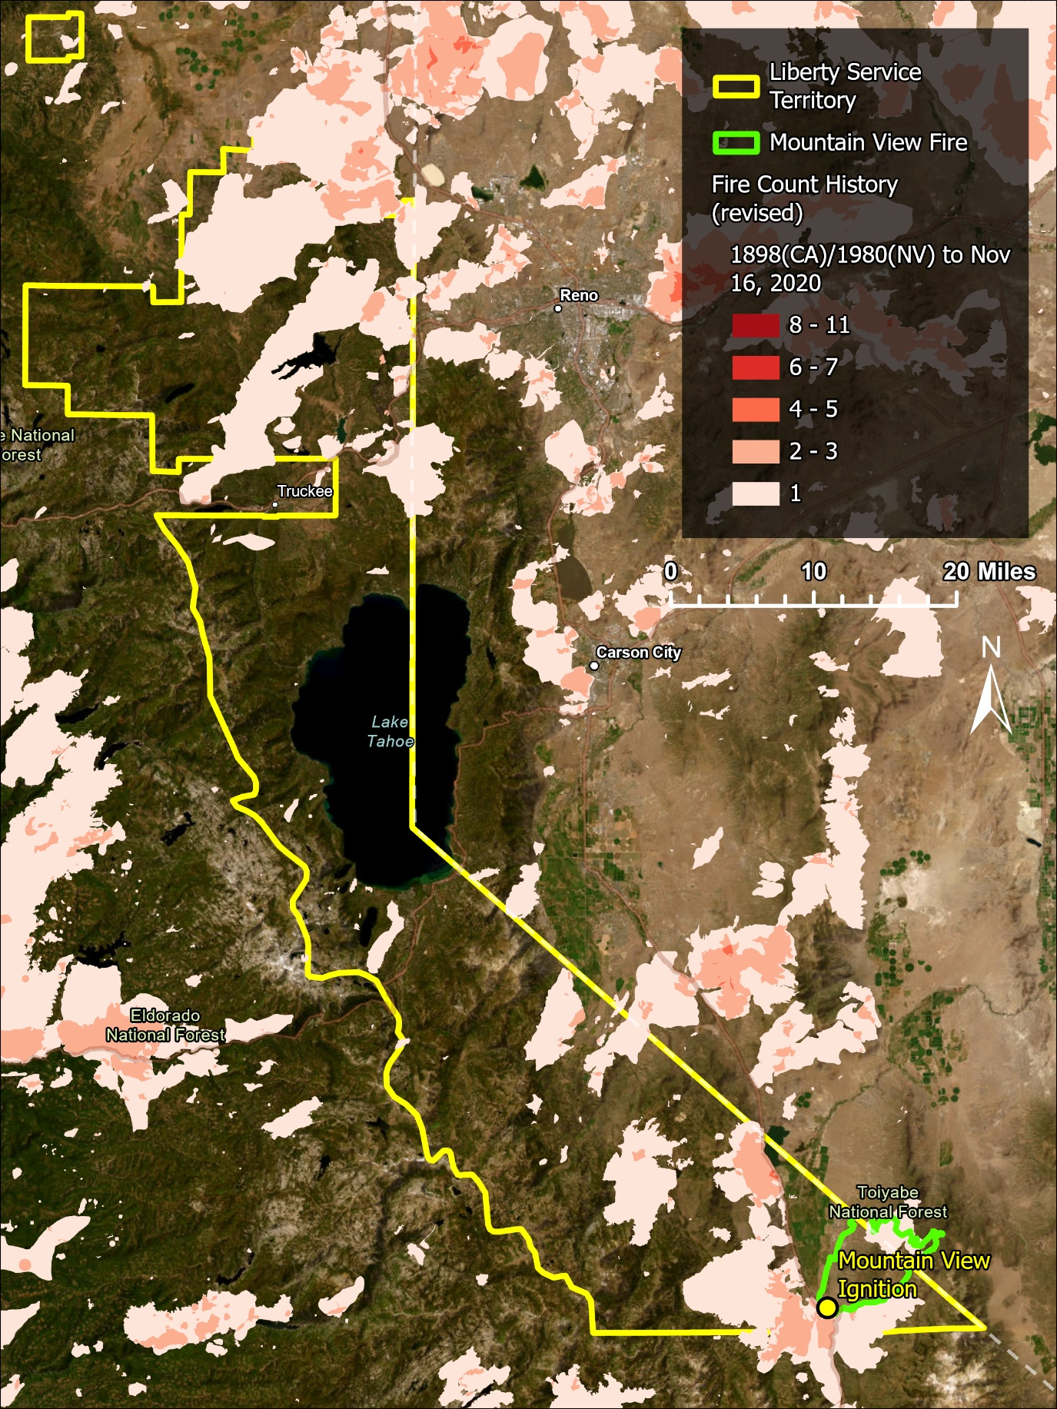
Figure 3 shows Liberty service territory (yellow outline) and the entire Mountain View Fire burn perimeter (green outline), with the ignition location marked (yellow dot)., , Figure 3 reveals that most past wildfires in Liberty’s service territory concentrated in the area north of Lake Tahoe and in the immediate area within 5 miles of Walker.
Figure 4 below is a closer look at the Mountain View Fire area around the city of Walker, with Liberty service territory boundaries (yellow outline), Mountain View Fire burn perimeter (green outline), and ignition location marked (yellow dot)., , Figure 4 shows that the immediate vicinity around Walker historically had one to four wildfires, as denoted by the pale pink, pink, and orange regions. Liberty states that “Mountain View Fire’s perimeter had not seen any large fires in at least a decade,” which, while technically true, ignores the rest of the surrounding territory.
Figure 4 Revised:
Historical Fire Count around the Topaz Circuit
                - 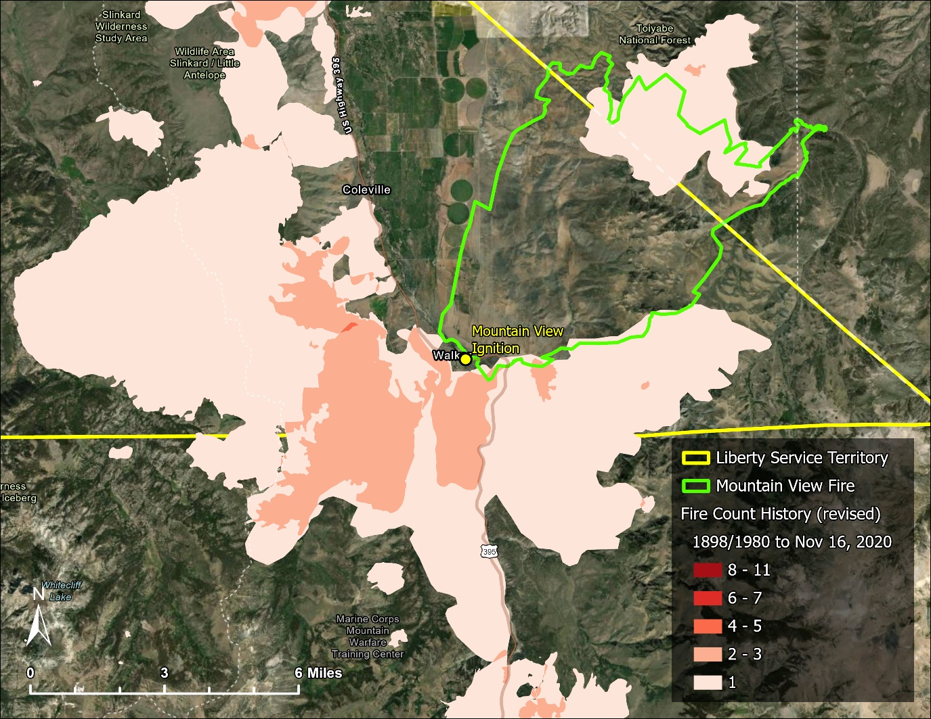

The Slink Fire ignited on August 29, 2020, and was contained on November 13, 2020, only four days before the Mountain View Fire ignited. Figure 5 below focuses on the area around City of Walker, and highlights the Slink Fire, the most recent wildfire in the immediate vicinity. Specific map features include Liberty’s service territory (yellow outline), Mountain View Fire burn perimeter (red), and Slink Fire burn perimeter (purple)., , The Slink Fire burned 26,752 acres and caused evacuations for the cities of Walker and Coleville and the temporary closure of Highway 395., ,

Figure 5 Revised:
Mountain View and Slink Fires, November 2020
                - 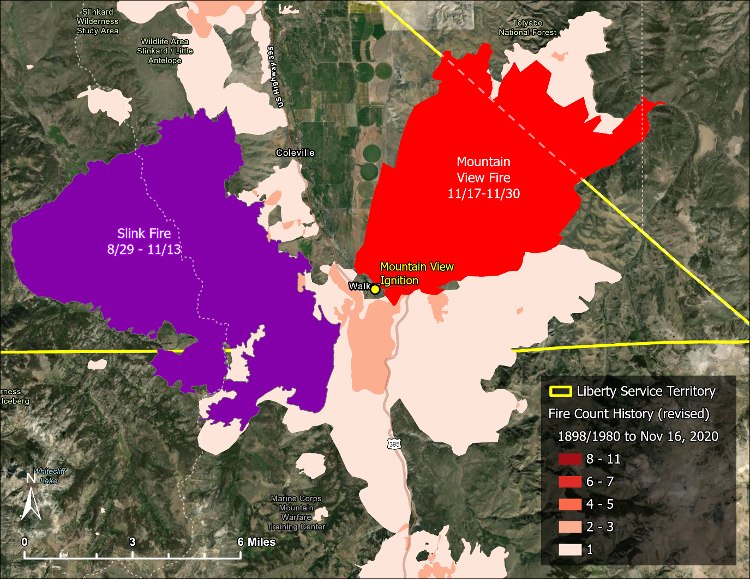

CAL FIRE (Attachment 9).
The criteria for inclusion are fires with perimeters ≥10 acres in timber, ≥50 acres in brush, or ≥300 acres in grass, and/or ≥3 damaged/ destroyed residential or commercial structures, and/or caused ≥1 fatality. Cooperating agencies submit perimeters ≥10 acres. Not all qualifying fires are included due to changes to inclusion criteria over the years: 488 total fires from the CAL FIRE Redbook Large Damaging Fires list are missing from the Fire Perimeter data. See the geodatabase metadata for more details.
BLM Nevada Wildfire Intelligence, “Nevada Wildland Fire Perimeters,” https://nvfireintel-nifc.hub.arcgis.com/, accessed December 7, 2025 (Attachment 12).
Liberty’s response to data request CalAdvocates-LIB-A2506017-006, Question 2 (Attachment 10).
CAL FIRE (Attachment 9).
California Energy Commission, Open Data Portal, Administrative Boundaries, “Electric Load Serving Entities (IOU & POU),” https://cecgis-caenergy.opendata.arcgis.com/, accessed December 7, 2025 (Attachment 8).
Liberty’s response to data request CalAdvocates-LIB-A2506017-006, Question 2 (Attachment 10).
CAL FIRE (Attachment 9).
California Energy Commission (Attachment 8).
CAL FIRE (Attachment 9).
Ex. Liberty-04 at 10. Liberty asserts that a lack of past fires meant fuel buildup increased wildfire intensity, but that implies wildfire was inevitable (either a place historically has many fires and thus fire-prone, or fuel-rich from lack of fires and thus fire-prone).
CAL FIRE (Attachment 9).
Liberty’s response to data request CalAdvocates-LIB-A2506017-006, Question 1, GIS geodatabase file “WEMA_RequestedData.gdb” (Attachment 10).
CAL FIRE (Attachment 9).
CAL FIRE (Attachment 9).
The Pine Tree, “Slink Fire Grows to 11,000 Acres, Evacuations Lifted, Hwy 395 Reopens & Smoke Output Drops,” September 1, 2020, https://new.thepinetree.net/?p=106522, accessed December 7, 2025 (Attachment 13).
NBC News 4 and Fox 11, “Slink Fire grows to 26,752 acres with 86% containment; evacuations lifted,” September 28, 2020, https://mynews4.com/news/local/slink-fire-west-of-coleville-grows-to-4700-acres-5-contained, accessed December 7, 2025 (Attachment 14).
CAL FIRE (Attachment 9).

